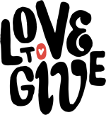

**LOVE TO GIVE**

**Project Education Sweden – December 2024**

**Micro-MBA 2024**

This year’s Micro-MBA course is complete and 9 of the 10 candidates graduated in our end of year celebration at the centre. Please see the picture below showing the candidates with their Graduation Certificates and with the two course facilitators and mentors, Alice and Asiphe.

Every Thursday afternoon during the final months of the course, we worked through each business’ weekly Money Management sheet. We discussed their businesses in detail and worked through any challenges or issues together. We had interesting class discussions on common problems. We also made sure that each candidate knew how many products each business needed to sell each day to achieve their sales target.

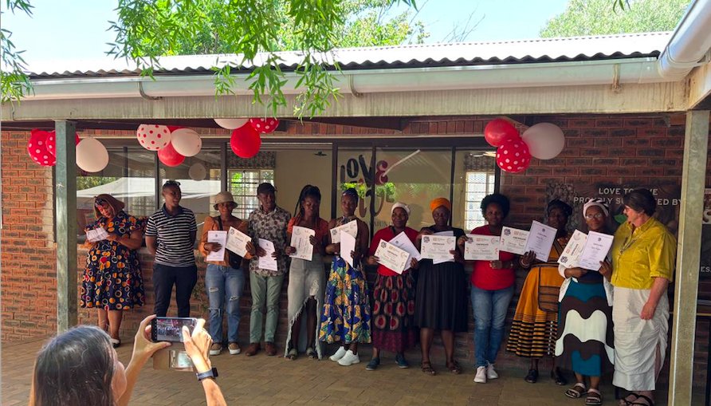

**Business Bridging Course and Micro-MBA 2025**

We completed the Business Bridging Course with all the people who started on Love to Give’s Citizen Connect programme in July and are giving people who have done well in the bridging course and have a viable business idea the opportunity to do the Micro-MBA. We interviewed 7 potential Micro-MBA students last week and 6 of them have been accepted onto the course.

We will be interviewing a further 6 people in January who are showing great potential on the Business Bridging course that we run on Fridays. We need to understand their business ideas and confirm their interest in the Micro-MBA before accepting them.

We hope to have 12 people on the Micro-MBA which will start in February 2025.

**Previous Businesses supported by Project Education**

In November, Nomajama Jikela and Gloria Fezela visited small businesses in Kayamandi whose owners completed the Small Business Course at Love to Give supported by Project Education before the Covid pandemic. The following businesses are still going strong.

1. Bulelwa Tito, who completed the business course sponsored by Project Education in 2018, has gone from strength to strength. She now has a partner, Lerato, and they create custom made garments for special occasions including suits. They work for a number of clients doing Cut, Make and Trim and are also creating table linen, scatter cushions and some craft items sewn in shweshwe fabric. They are also offering six month sewing courses within Kayamandi helping students to draft basic patterns and sew garments.

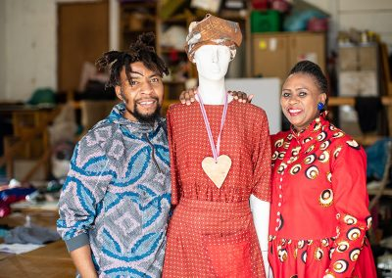

1. Lindiswa Ngamlana is now working for the municipality. She is also a Sangoma (traditional healer) and charges for her healing services. She makes and sells clothing for traditional healers.
2. Phatiswa Tetyana has expanded her vetkoek business and is still selling her vetkoek at schools in Kayamandi.
3. Nothandekile Ngalo is still sewing on her own making pillows and clothing. She takes orders from people at her church for traditional attire and also has a mending business. She attends a sewing club doing embroidery and sells her embroidered items through the legacy centre to tourists visiting Stellenbosch. See some of her products pictured below:

