Hlathi Drive
Asanda Village
Strand
7140

Principal: Mr. M. Qantolo
Contact: 071 283 4465

Phone: 0746018674 /0712834465 Email address: qantolom@yahoo.com

THIRD TERM REPORT
Nothing much has happened since my second term report and the school is still doing well and the children are happy. All that is worth mentioning is how much we have are grateful by the continued support in clothing our children. The school gets to be beautiful because of the uniform and we are happy that you have helped us in that regard. The features for this term are as follows : Resignation of our Deputy Principal (Vice Principal), Bereavement, Heritage Months , teacher’s day, Grade 7 valedictory and what is happening around us( Current news)

RESIGNATION OF OUR DEPUTY PRINCIPAL
After serving the school for 4 full years Ms Nikelwa Gqeba has tendered her resignation and is no longer part of the school as from 1 October 2018 and she will be remembered by the school as an energetic soul who was always goal driven. Her reason for resignation was family reasons. The school had a task of filling her shoes on a temporary basis until we find a permanent deputy principal.

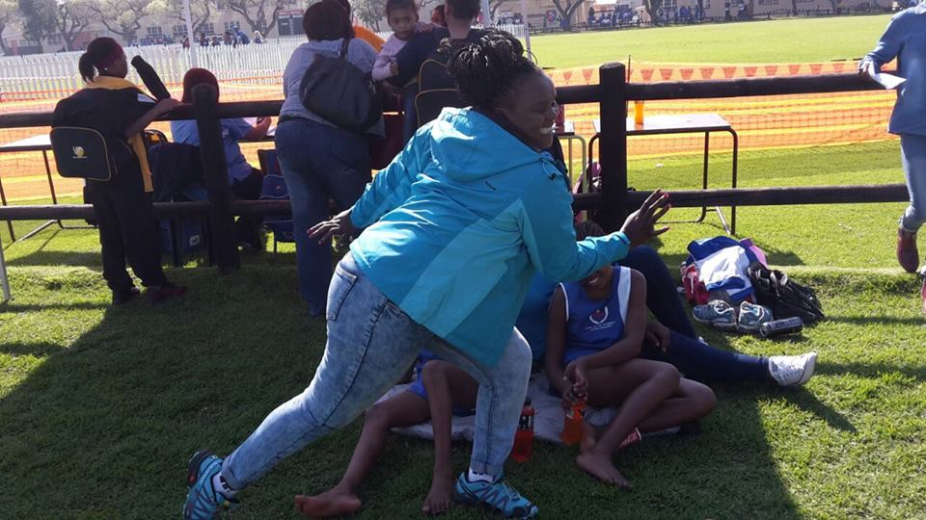
Ms Nikelwa Gqeba the outgoing deputy principal
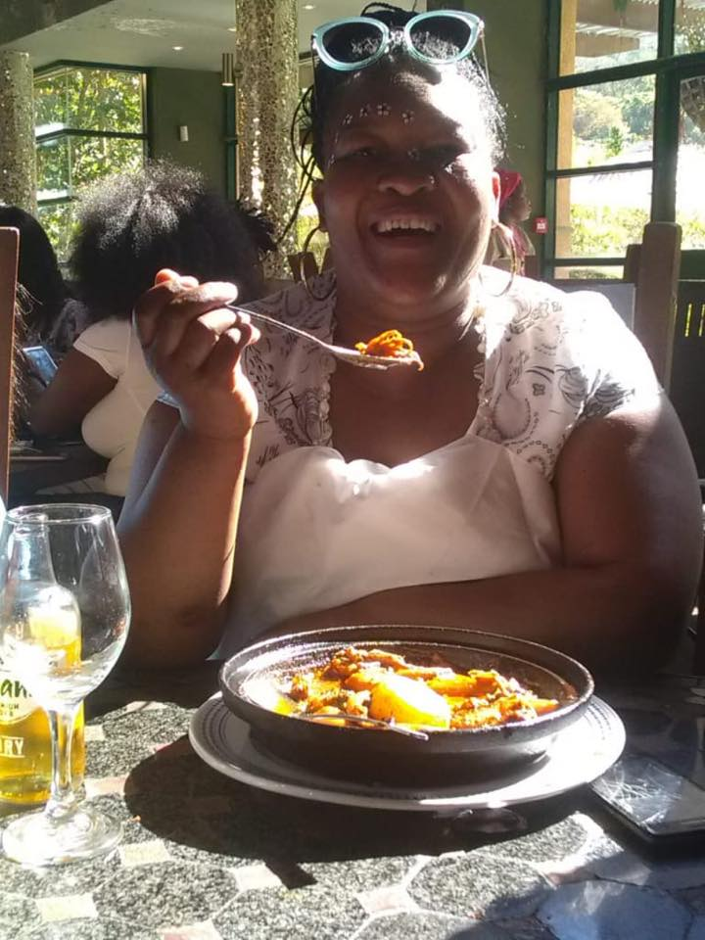
The new acting deputy principal (Mrs Nqotole)
Bereavement
It is with great sadness and painful to announce that we lost two learners in a space of two weeks to unrelated illnesses or incidents. One was doing grade 1 and her name is IMINATHI NDZIMA, a 7 year old that succumbed to stomach bug after 2 days. In the following week we had to bury another one doing grade 6 and her name is SESONA HLUKANISA who succumbed to liver infection. The children and the teachers were very devastated and we haven’t fully recovered from this blow
Heritage month
Every September in South Africa in particular the 24th September of each that is celebrated as the national heritage day. What this means is that we remember our roots and were we come from by wearing our clothes and eat food that our fore fathers eat. Please see it in colours
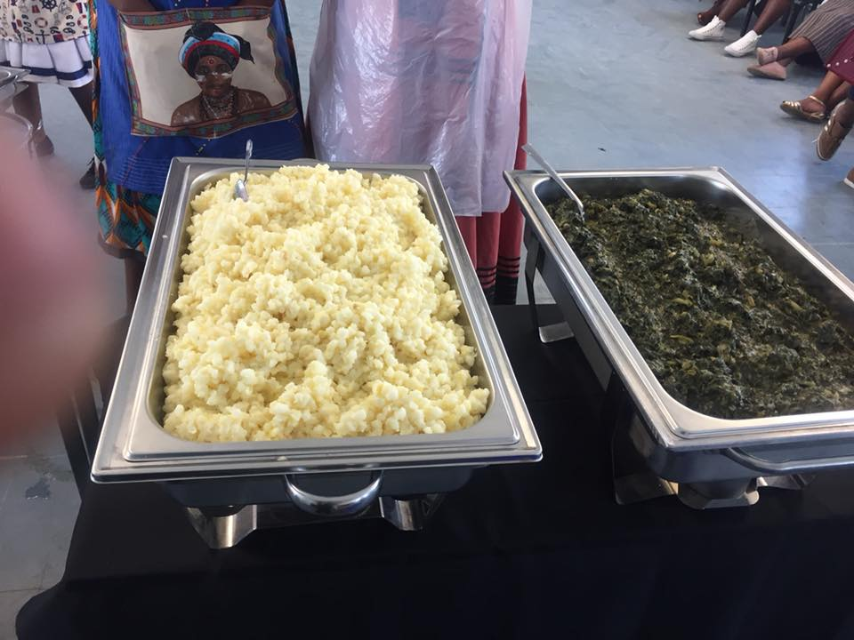
African meal called Samp on the left and spinach
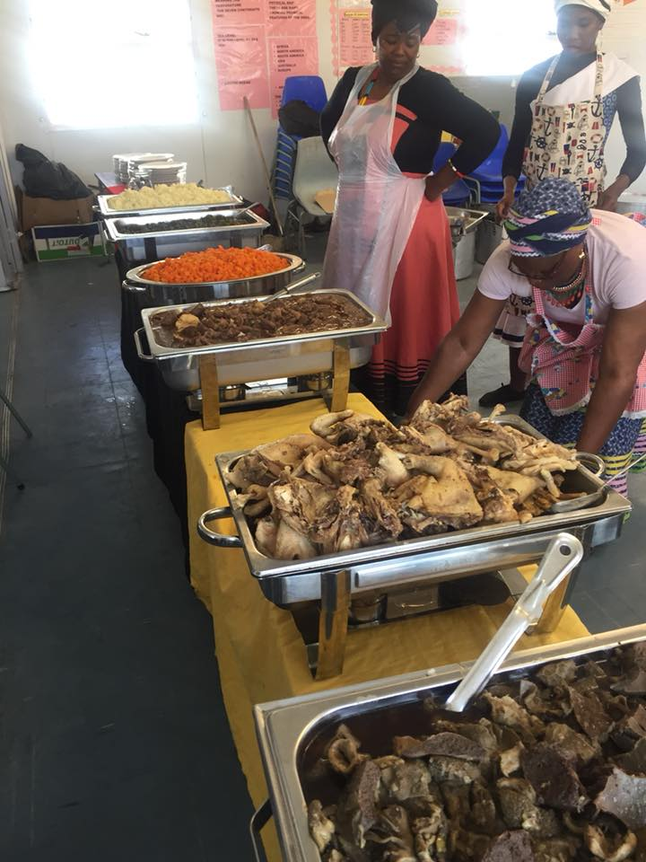
From far picture : Samp, spinach, carrot, beef, ‘umleqwa’ freshly slaughtered chicken, offal

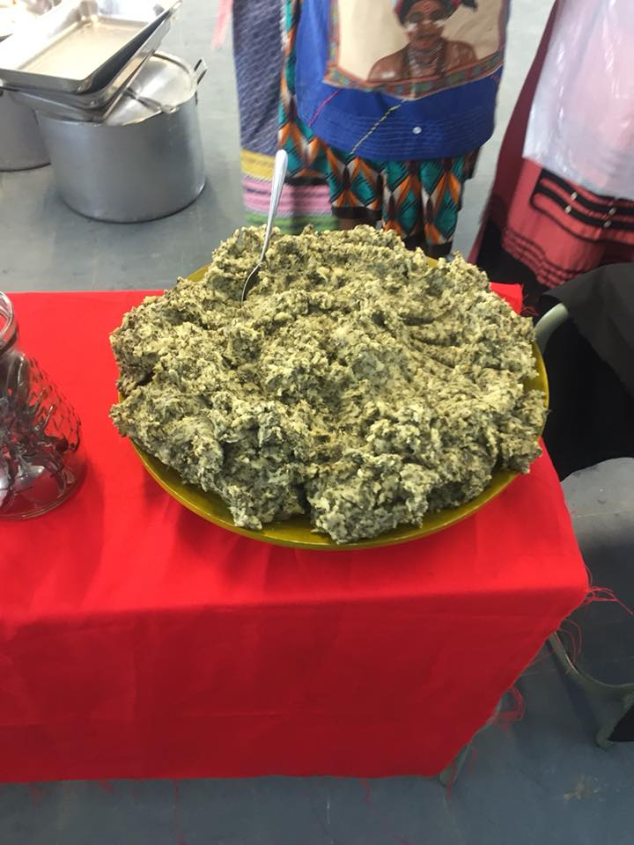
Spinach mixed with mealie-meal (popular among Xhosa people)

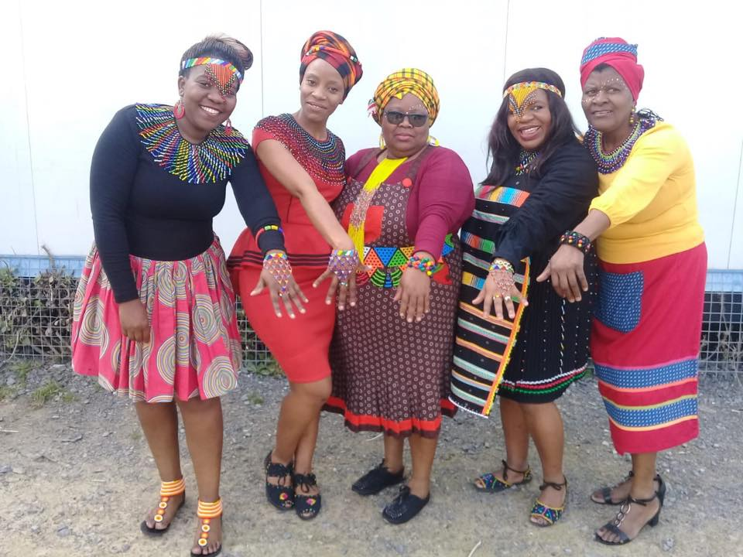

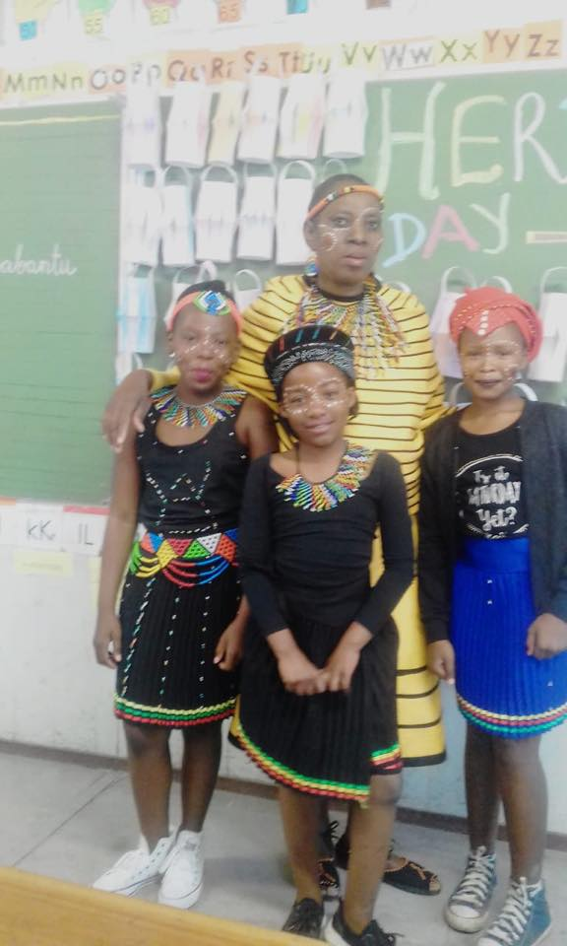
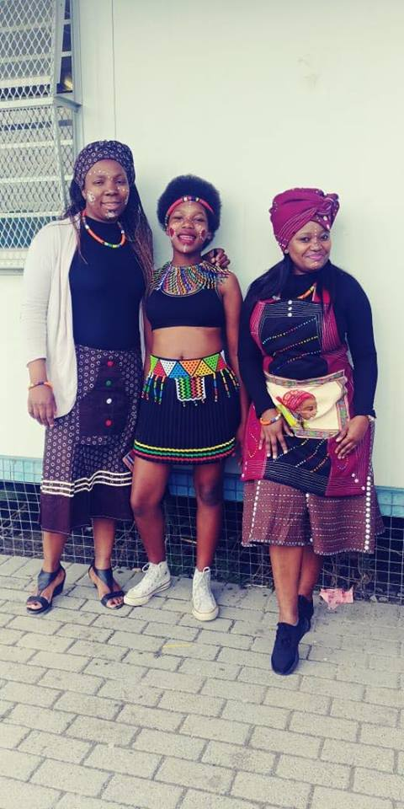

Teacher’s day
Every 5th October is World so this year was no different for us as well . The teachers went out for lunch
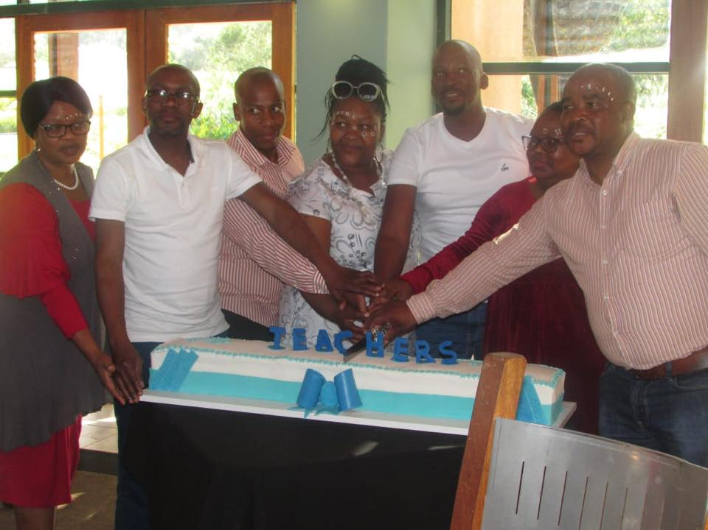
The School Management Team cutting the cake
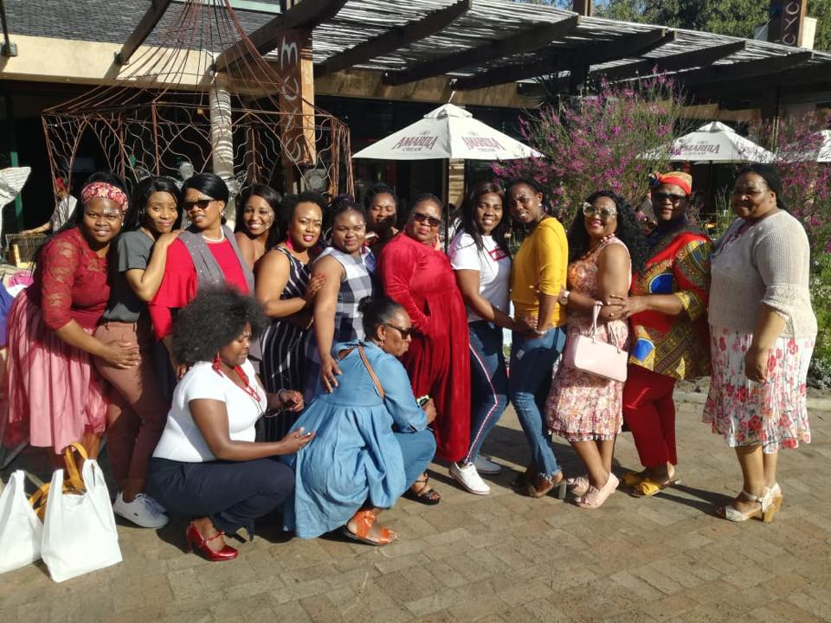
Female teachers looking beautiful
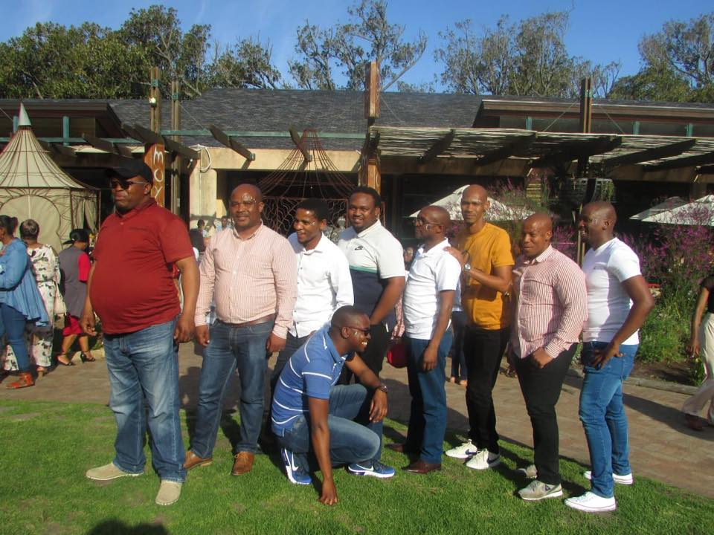
Male teachers
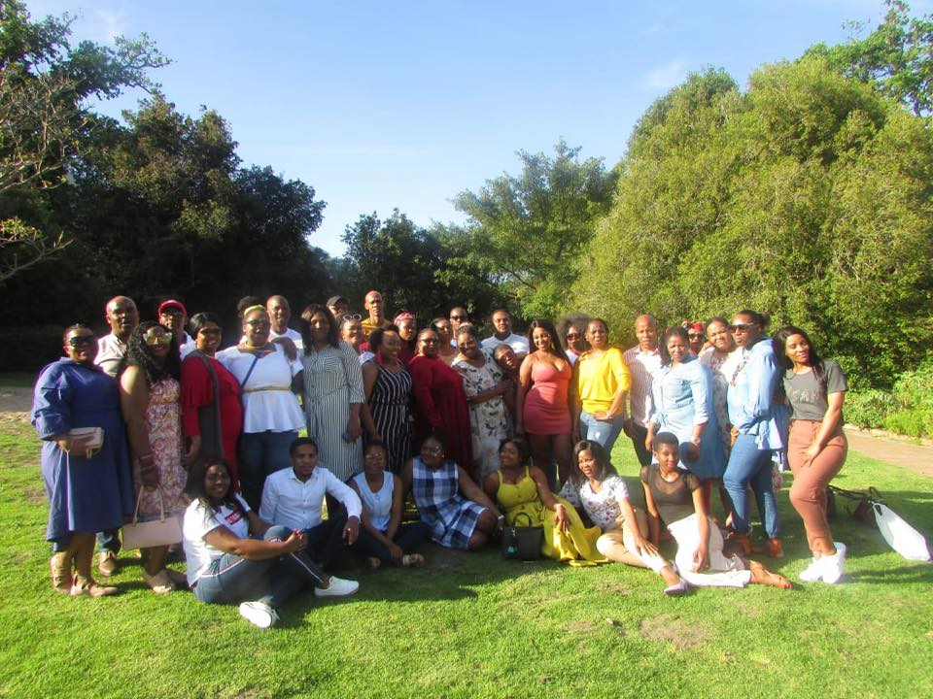
The entire staff

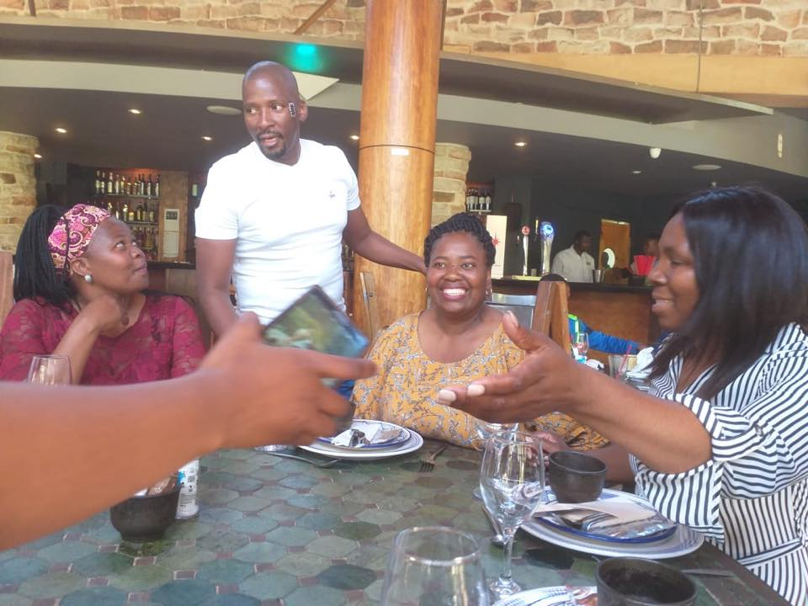

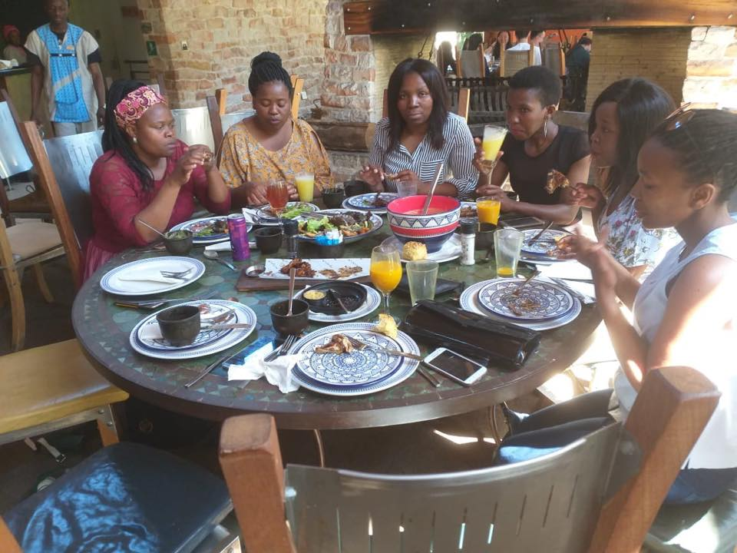

Grade 7 Valedictory
Once more this year we are taking our grade 7s out for a farewell that will on the 15 November 2018 and there will be a gala dinner and awards

CHRISTMAS TINTO IN COLOURS
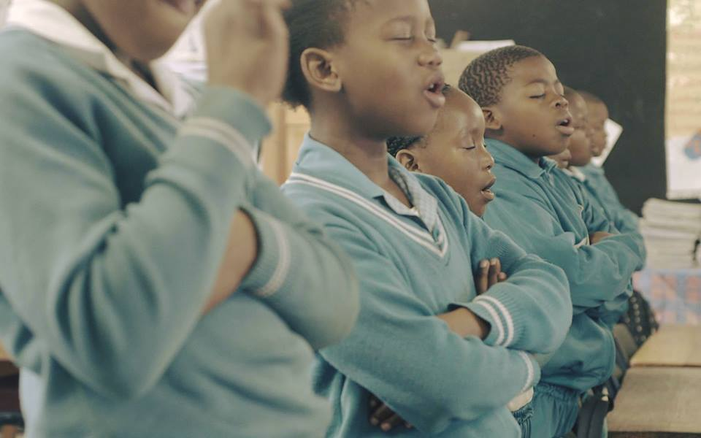
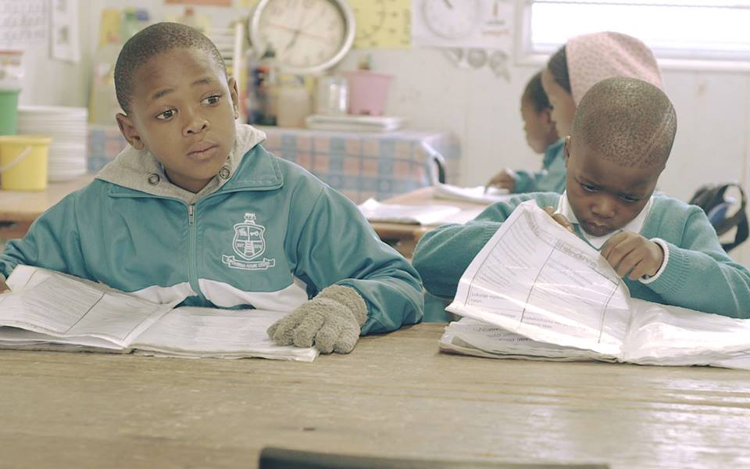

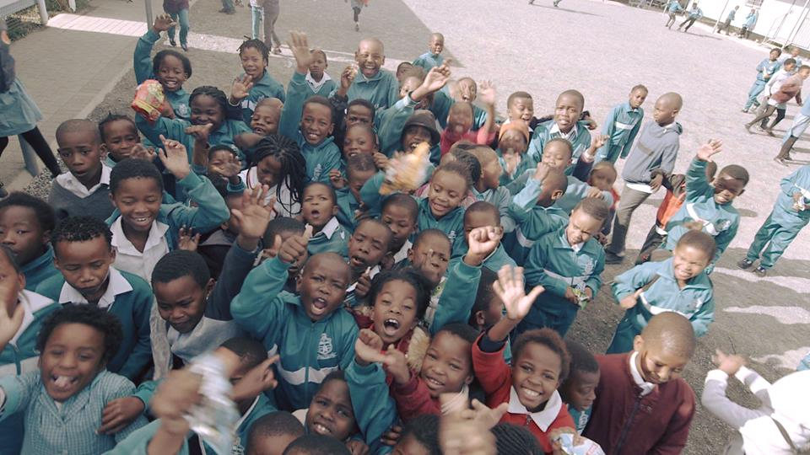

Conclusions
I would like to thank project education and its directors for the support that they give Christmas Tinto Primary, I know that I have said this before but I will say it once again and that is in an environment like (poverty stricken) everything is appreciated whether its big or small. We value the input and you make our lives a little easier each day. You help us along the journey towards excellent education.
On a sour note though violence in school has escalated recently a teacher was stabbed to death in a school. It was not the only incident but one of many but we will not be deterred because we are teachers and we were born to do this. Even if they take on us with knives and a barrel of a gun but we will not give up on them.
I am hoping to speak to you soon at the middle of November bringing you our concert photos that will be on the 27 October 2018, our grade 7 valedictory photos and other news
On the 5-7 December 2018 we will embark on a 5 year strategic plan that will look at how we want to see Christmas Tinto Primary in 2023. It has been dubbed as project 2023 and at the centre of that is quality education deliverance.
Mphicothi Qantolo
Headmaster

