Hlathi Drive
Asanda Village
Strand
7140

Principal: Mr. M. Qantolo
Contact: 071 283 4465

Phone: 0746018674 /0712834465 Email address: qantolom@yahoo.com

SCHOOL PROFILE FEBRUARY 2018
SCHOOL DETAILS
SCHOOL NAME : CHRISTMAS TINTO PRIMARY SCHOOL
EMIS NNUMBER : 0100000217
PHYSICAL ADDRESS : HLATHI DRIVE, ASANDA VILLAGE, STRAND (7140)
POSTAL ADDRESS : P. O. BOX 3070, SOMERSET WEST (7129)
NAME OF PRINCIPAL : MR. MPHICOTHI QANTOLO
SCHOOL CONTACTS : 074 601 8674
PRINCIPAL’S CONTACTS : 071 283 4465
SCHOOL EMAIL : Christmastintops@gmail.com
PRINCIPAL EMAIL : qantolom@yahoo.com
STAFF ESTABLISHMENT : 41 teachers, 2 admin clerks and 3 General Assistants
NUMBER OF CLASSES : 35
SCHOOL ENROLMENT : 1472

SCHOOL FEES : NO FEE SCHOOL
START OF THE YEAR
Let me take this opportunity to wish everyone a happy new year. The school started very well with less stress than last year. We have enough classrooms with means less overcrowding but the downside of that is lack of tables and chairs. We have accepted or admitted 182 new babies(grade 1 learners). The school started well on time and as expected. The only down side is the number of children in our community who are still sitting at home waiting access to schooling. They cannot get in because all the schools in the Heilderbeg basin are full. There about 133 of those learners.
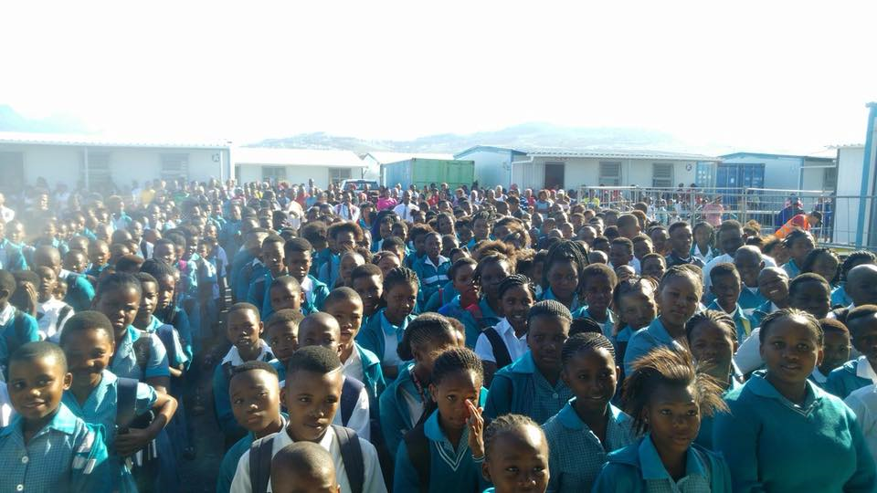 first day of school
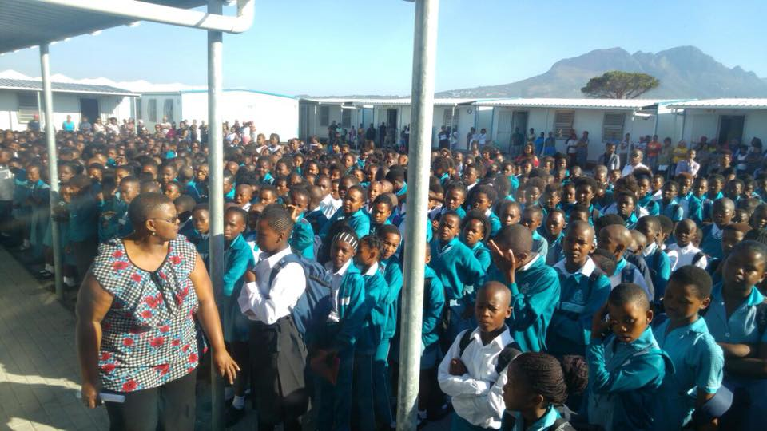 first day of school
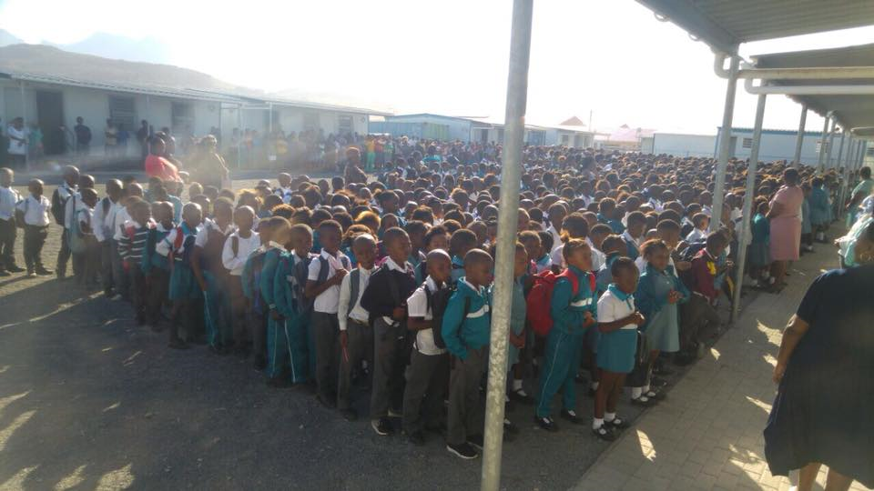
First day of school
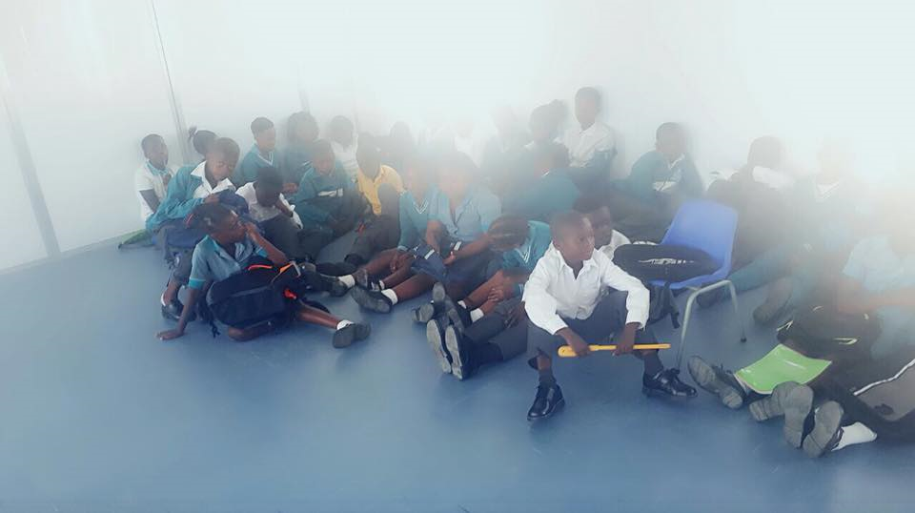 challenges of chairs and tables. Learners sitting on the floor
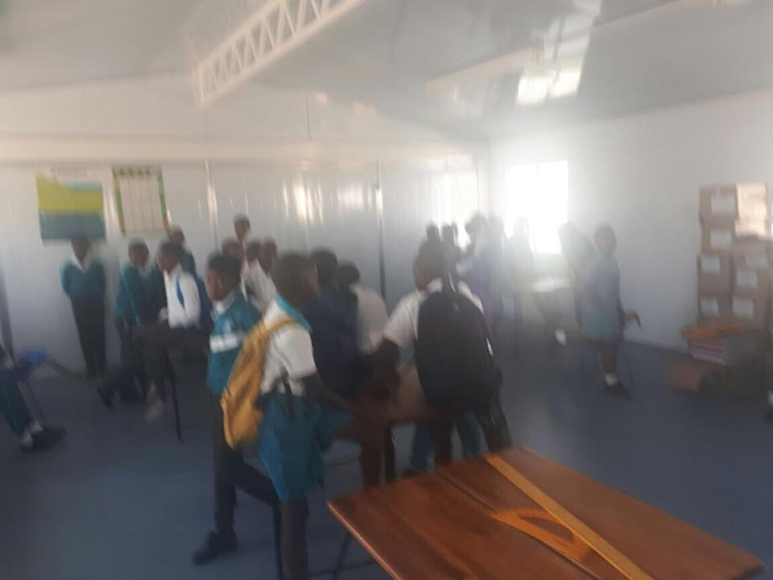
DROUGHT
Cape Town has been hit hard by the drought and we are approaching day zero (day 0) on the 12 April 2018. What that means is that the dam levels in that feeds the entire City with water will be below 13% and it will be difficult to access that water. This means now to avoid day zero people must use water wisely. Everyone now in Cape Town is encouraged to use 50L of water per day for cooking, bathing and drinking. The nice thing though is that school will not close if there is no water in the city. Tanks will be installed I schools and water would be transported to schools and each child will use 10L of water per day. We will use the water in the ocean to flush toilets.
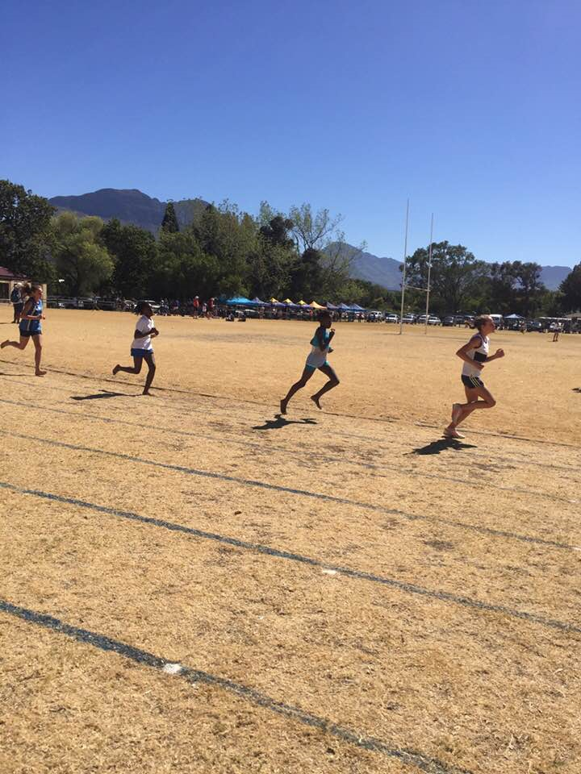
Evidence of drought (the second leaner in the race is from our school)
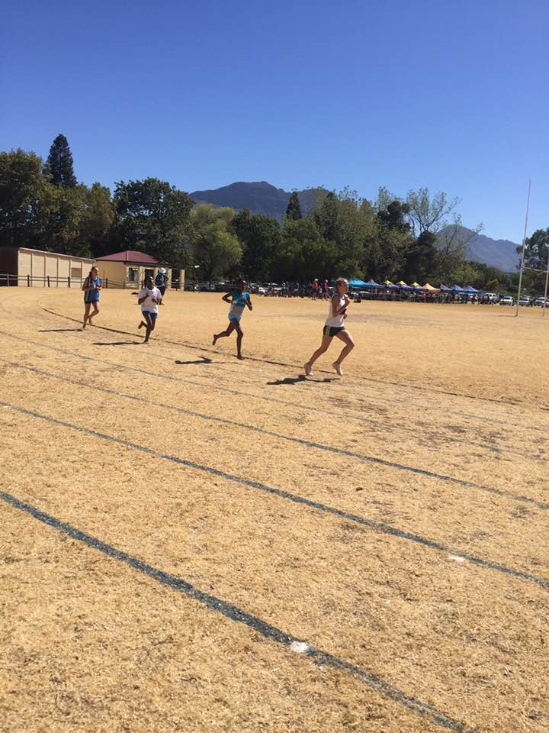
You can’t find a green patch of grass right now in Cape Town (Learner in second if from our school)

SCHOOL’S ACHIEVEMENTS THIS YEAR
RESULTS 2017
The school has done well as we managed to have 95.7% pass rate for the school starting from grade 1- 7
GRADE | ACTUAL NUMBER OF LEARNERS | ACTUAL NUMBER WHO PASSED | PASS PERCENTAGE
GRADE 1 | 167 | 135 | 81%
GRADE 2 | 196 | 183 | 93%
GRADE 3 | 199 | 192 | 96%
GRADE 4 | 217 | 211 | 97%
GRADE 5 | 224 | 222 | 99%
GRADE 6 | 221 | 220 | 99%
GRADE 7 | 186 | 186 | 100%
The significance of these results is that when you have children that are less worried about how they look then you are more likely to get results. The uniform that they get from people like you is helpful because they don’t have to worry about other things but only their books.
ATHLETICS
The athletics season has started and our learners have done well on the first round.
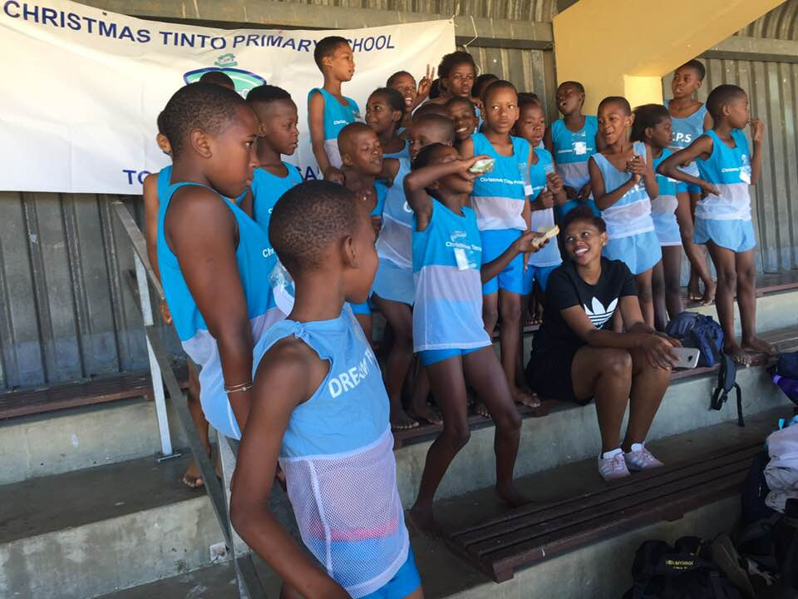
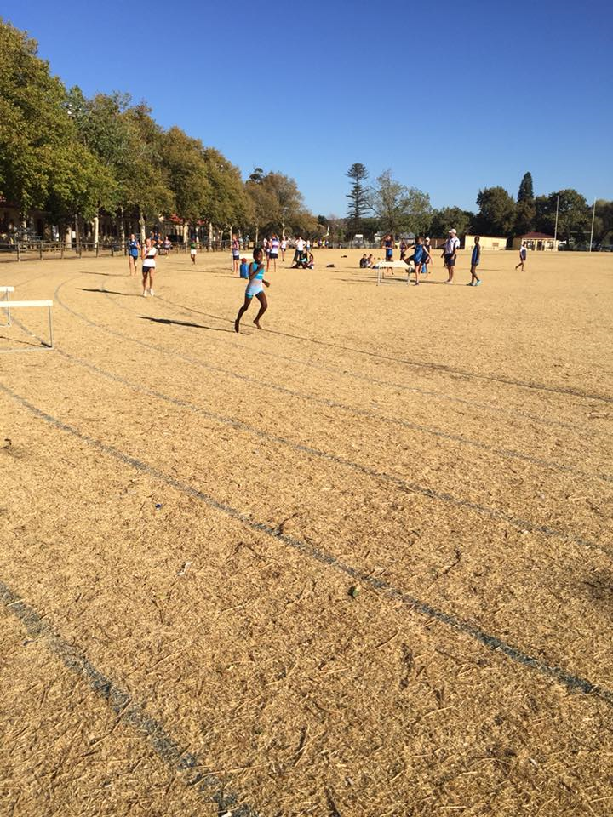
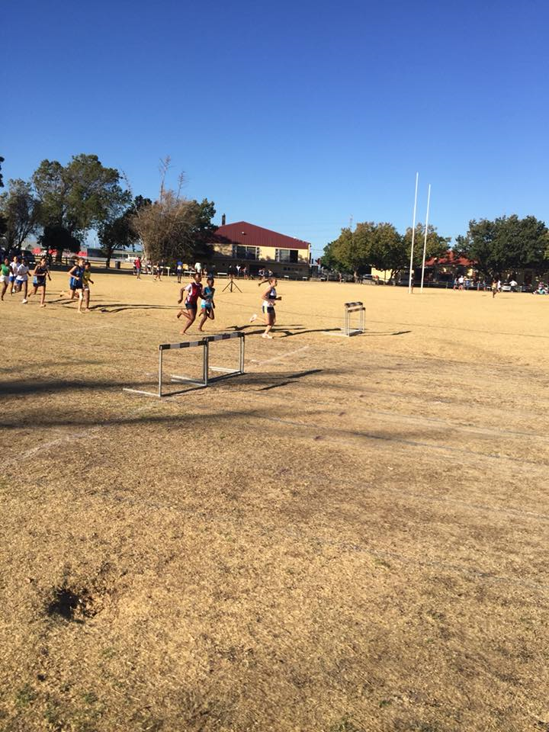
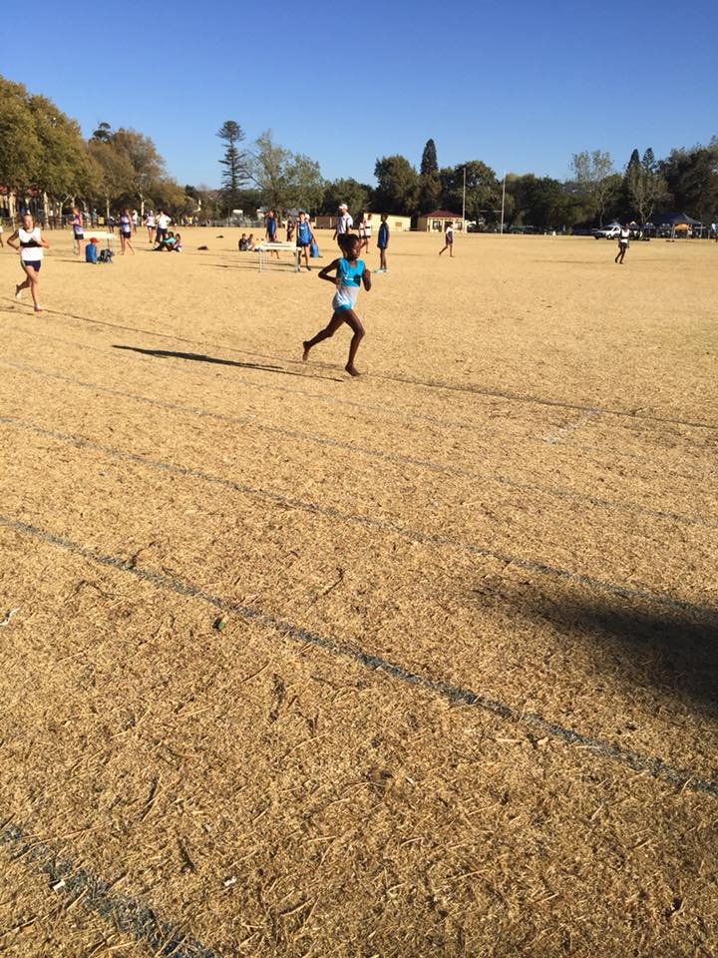

UNIFORM
We very grateful and will forever be indebted to you Mrs. Ohlsson for the effort and the love you have shown to our kids. I could see the passion in your eyes when you visited the school. A special mention to each and every individual who contributed to this initiative in AFRIKA we “ Umntu ngumntu ngabantu” which means “ a person is a person through other people” or “No man is an island”. I have said it before and I am going to say it again that the uniform is much more than a piece of cloth. It brings honor and dignity to the learner. It says that you are part of us
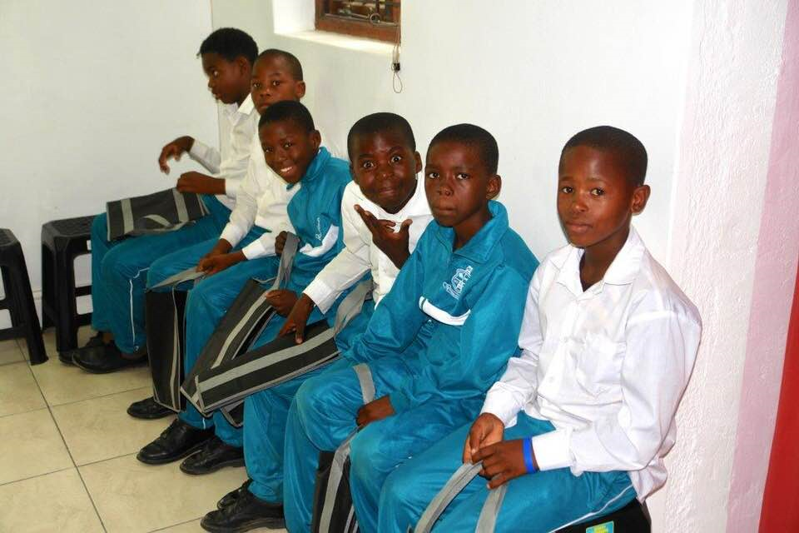
CHILDREN AT IMIBALA RECEIVING THEIR UNIFORM THAT WAS SPONSERD BY PROJECT EDUCATION
As a school we are very much grateful to everyone who contributed to this good initiative.
SUCCESSES
I prefer not to talk about the challenges this year and that’s the attitude that as a school we have adopted. It is not to say there are none but we prefer “to make lemonade”.
- We have managed to improve our results by 5% from 2016
- Had a wonderful Cross-country season in 2017
- We have received 5 new classrooms
- We have 10 toilet cubicles for Girls and 5 for boys and that will help us a lot
- Teacher Awards that we started in 2017

Photos of Teacher Awards
This was an event that we held on 5 October 2017 when the world celebrates teachers’ day. We decided as the school management team to recognize and acknowledge the teachers for the grate work that they do with these children under trying circumstances.
We had the following categories
- Excellency in language teaching
- Excellency in Mathematics teaching
- Excellency in Science
- Excellency in History
- Excellency in Life Skills
- Ubuntu(Humanity) award
- Teacher of the year award
- Excellent attendance
- The peoples’ choice award
- Excellency in Life skills (Foundation phase, grade 1-3)
- Excellency in Mathematics (Foundation phase, grade 1-3)
- Excellency in Isixhosa Home Language (Foundation Phase, grade 1-3)

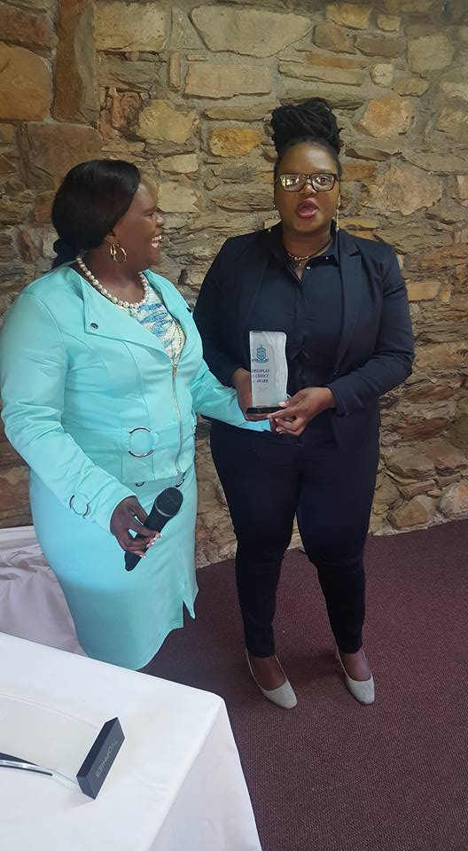
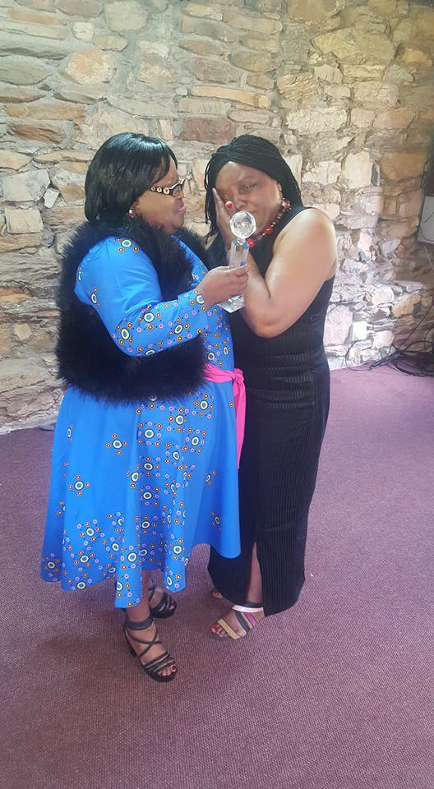
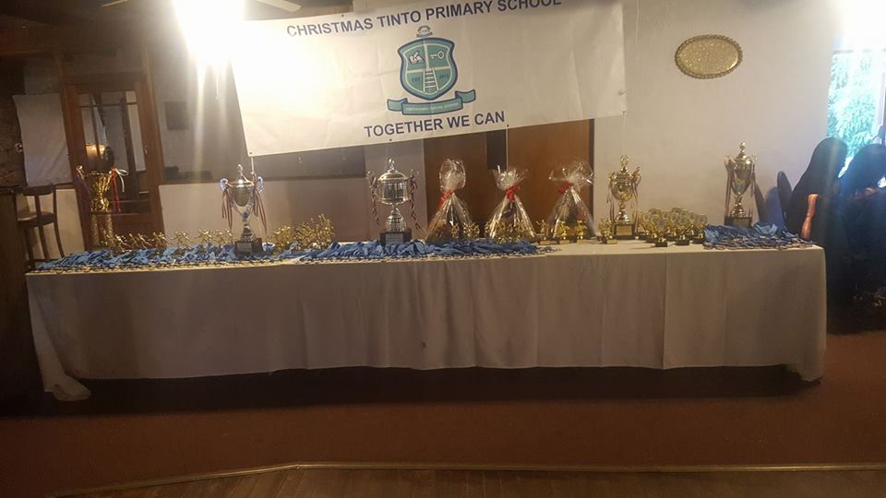

School Library
Our results have now improved because of the Library
Conclusions
I would like to take this opportunity to give a commitment to you that I am hoping to improve the communication now so as to keep you informed every step of the way. We will try to stick to the 5th of every month for updates and newsletter even if its 2 pages sometimes.
Mphicothi Qantolo
Headmaster

